7 SEPTEMBER 2015
FOR IMMEDIATE RELEASE
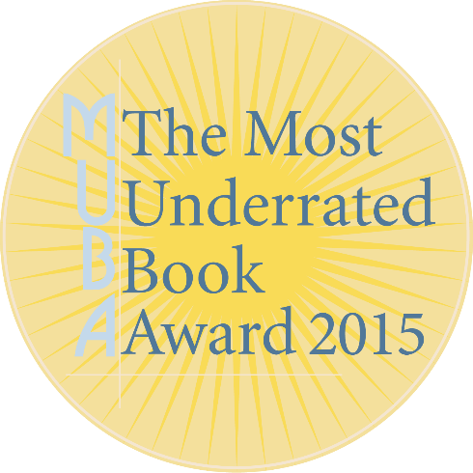
SHORTLIST ANNOUNCED:
THE MOST UNDERRATED BOOK AWARD 2015
The Small Press Network (SPN) is thrilled to announce the three books shortlisted for the 2015 Most Underrated Book Award (MUBA):

Isabelle of the Moon and Stars by S.A. Jones
UWA Publishing

The Grapple Annual No. 1 edited by Duncan Felton
Grapple Publishing

Funemployed: Life as an Artist in Australia by Justin Heazlewood
Affirm Press

The MUBA is an annual award that aims to shine a light on some of the outstanding titles produced by small and independent Australian publishers that, for whatever reason, did not receive their fair dues when first released.
Past winners of the award include: A Wrong Turn at The Office of Unmade Lists by Jane Rawson, published by Transit Lounge (2014), Fish-Hair Woman by Merlinda Bobis, published by Spinifex Press (2013) and inaugural winner The Cook by Wayne Macauley, published by Text Publishing.
The 2015 shortlist will now be read and deliberated by a trio of judges who were chosen for their bookish integrity, passion and commitment to the Australian publishing world. And the winner of the 2015 MUBA will be announced on the night of Friday 20 November, at the Wheeler Centre in Melbourne. In the meantime, SPN will be promoting the three-book shortlist to bookshops across Australia.
For more information about MUBA and SPN, please contact:
- Hannah Cartmel (acting SPN General Manager) hannah@smallpressnetwork.com.au
- Danielle Binks (SPN board member in charge of MUBA committee) daniellebinks@gmail.com
And if you would like to reach out to publicists about specific shortlisted titles:
- Isabelle of the Moon and Stars • UWA Publishing
Charlotte Guest • charlotte.guest@uwa.edu.au • 08 6488 3670

- The Grapple Annual No. 1 • Grapple Publishing
Duncan Felton • editor@grapplepublishing.com • 0438 822 036

- Funemployed: Life as an Artist in Australia• Affirm Press
Keiran Rogers • keiran.rogers@affirmpress.com.au • 03 8695 9639

